**Exercises Iteration**

**Exercise 1**

a) With this program you can calculate the product of a number of numbers. The program continues to ask the user for whole numbers until they enter a 0 (zero).

When the user enters 0, the product is printed.

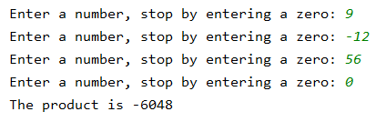

b) Extend your exercise and print also how many numbers were entered.

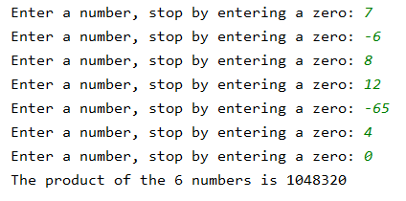

**Exercise 2**

Write a program to count how many zeros and sixes you can find in a number.

Test with real numbers which do not start with the number 0. If you do enter a number starting with the digit 0, it will be omitted e.g. 0125 is stored as 125.





**Exercise 3**

Write a program that reads in your age and that of your father. Then calculate when your father is exactly twice as old as you.

Please note that for some combinations this situation is not possible.

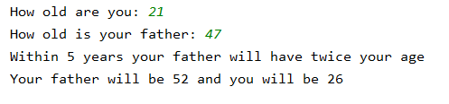

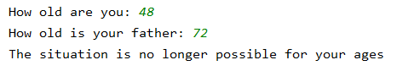

**Exercise 4**

Write a program to play 'Higher Lower’. The computer takes a number for the player to guess. The game continues with tips like ‘Higher’ or ‘Lower’ until the player has guessed the number. At that point the program prints out how many tips the player needed to get to the result.

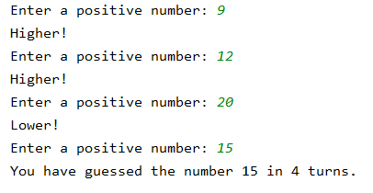

**Exercise 5**

Write a program to read a series of numbers (stop the input by entering 0).

Print the largest number and the smallest number entered as well as the difference between those numbers.

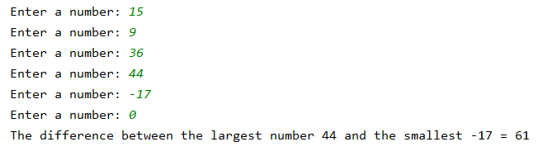

If no numbers are entered, except the 0 to end, print "No numbers entered.".



**Exercise 6**

Write a program that allows the user to print a series of numbers on the screen, each time separated by 3 dots.

The user first fills in a positive start number, then all numbers from that number up to and including 0 are printed on the screen.



**Exercise 7**

1. Write a program that calculates the sum of all numbers between 25 and 32 (including the boundaries).

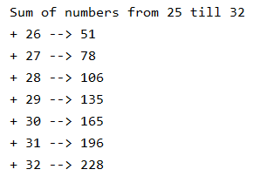

1. Adjust your program so that you can also enter the initial and final limits yourself.   
   Take the following situations into account:
   * Initial and final limits are equal
   * Initial limit is greater than the final limit

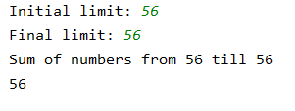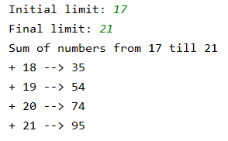

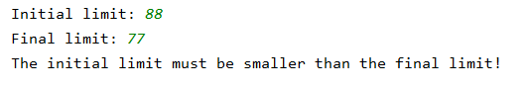

**Exercise 8**

Write a program that asks for a digit followed by the input of 10 numbers. As a result you get the number of numbers that ends on this digit.

Make sure that the output text changes appropriately when only 1 number ends on the final digit.

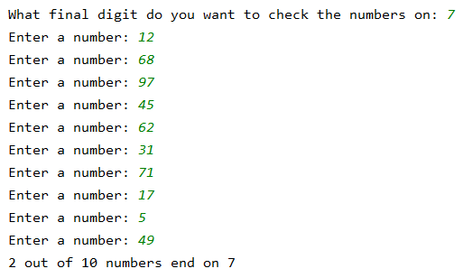

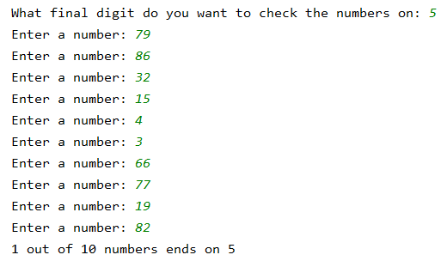

**Exercise 9**

1. Write a program that allows the user to print the following series of integers, for each number between 10 and 20.

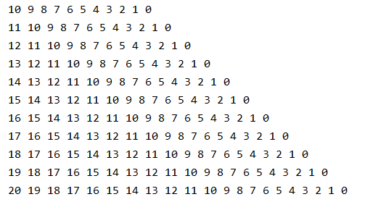

1. Adjust the exercise so that you only print the even numbers between 10 and 20. (You may not use an if).

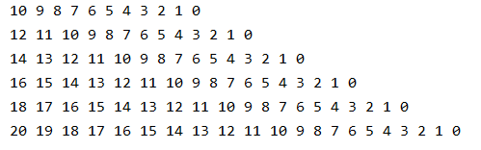

**Exercise 10**

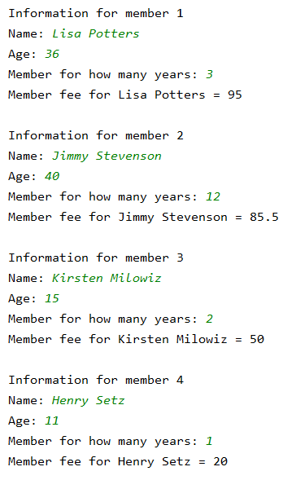Write a program to calculate the member fee for 4 members of a tennis club. For each of the 4 members, you must enter their name, their age and the number of years they are already member of the club.

Members pay according to their age:

* Younger than 12: €20
* Aged between 12 and 18: €50
* Older than 18: €95

If somebody is a member for at least 5 years, then he/she gets a discount of 10%.